# Section 13: Introduction – A Summary of the Buddha’s Forty-Five Years of Great Service to the World

In this section, we present a summary of the Buddha’s forty-five years of dedicated service to all beings, aimed at alleviating their suffering. Based on information from the Tipiṭaka, it is challenging to reconstruct an unbroken sequence of events from the years he spent proclaiming the Dhamma for the happiness and welfare of many. Therefore, we have compiled key events from this period into a series of subsections, each focusing on significant aspects of his life and teachings. These subsections will include important Dhamma messages and sermons, milestones in the expansion of his dispensation, his extensive walking tours, the locations where he spent the rainy seasons (vassa), and other noteworthy events.

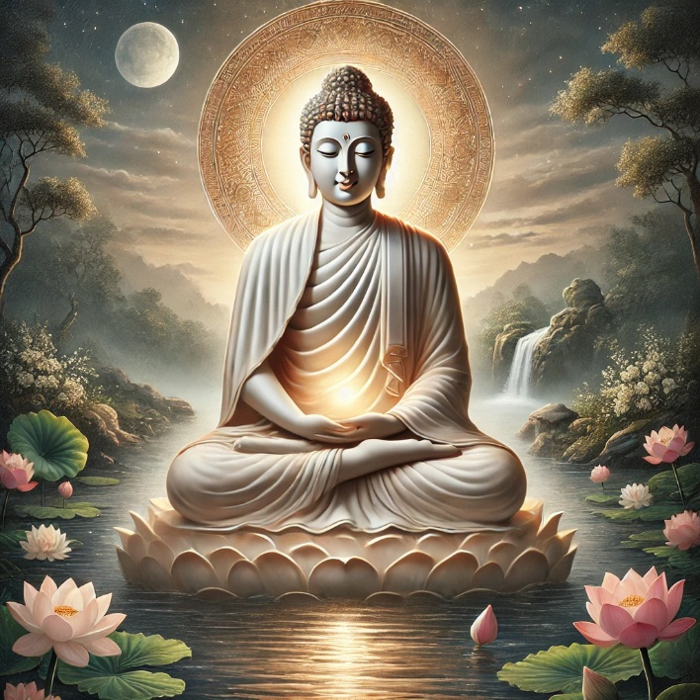

**The Buddha the Fully Enlightened One [1]**

# Vassa (the Rainy Season Retreat)

Vassa refers to the three- to four-month rainy season in ancient India, during which members of various religious sects would retreat into forests and hermitages for seclusion, ceasing their travels. During this time, their lay followers provided them with essential food and other necessities. The Buddha endorsed this longstanding tradition and encouraged his disciples to observe Vassa in a peaceful and disciplined manner. The rules for observing Vassa are explained in detail in the Vinaya Piṭaka.

# Age of 35 to 80 years

This series covers the period from the Buddha’s enlightenment (*Sambodhi*) at the age of thirty-five to his passing (*Parinibbāna*) at the age of eighty. According to scriptures and tradition, the Blessed One, guided by his boundless compassion (*mahākaruṇā*) and loving-kindness (*mettā*), travelled tirelessly from village to village, town to town, and province to province across the northern and eastern regions of ancient India (then known as *Jambudīpa*). He delivered sermons, offered advice, and provided guidance to people from all walks of life—kings, ministers, householders, wealthy merchants, the poor, including beggars, as well as criminals such as robbers. Regardless of caste or status, he showed all the path to liberation.

## Major States of Ancient India During the Time of the Buddha

During his missionary journey, the Blessed One travelled extensively across most of the sixteen great provinces (then called *Mahājanapadas*) of ancient northern India. To better understand the historical context, it is helpful to refer to a modern map based on scriptures and ancient texts. The map below highlights the major provinces (or kingdoms) and important cities that existed before and during the time of the Buddha. Below, we have compiled information about these regions from scriptures and other sources.

### Other sources:

The **Mahājanapadas** (solosa janapadas- see the map below) were sixteen kingdoms and aristocratic republics that existed in Ancient India from the sixth to fourth centuries of BCE…Two of the Mahājanapadas were most probably [*gaṇasaṅgha*s](https://en.wikipedia.org/wiki/Ga%E1%B9%87asa%E1%B9%85gha) (aristocratic republics), and others had forms of monarchy. Ancient [Buddhist texts](https://en.wikipedia.org/wiki/Buddhist_texts) (like the [*Anguttara Nikaya*](https://en.wikipedia.org/wiki/Anguttara_Nikaya)) make frequent reference to sixteen great kingdoms and republics that had developed and flourished in a belt stretching from [Gandhara](https://en.wikipedia.org/wiki/Gandhara) in the northwest to [Anga](https://en.wikipedia.org/wiki/Anga) in the east to [Asmaka](https://en.wikipedia.org/wiki/Asmaka) in the southern part of the [subcontinent](https://en.wikipedia.org/wiki/Indian_subcontinent). They included parts of the trans-[Vindhyan](https://en.wikipedia.org/wiki/Vindhya_Range) region, and all had developed prior to the rise of Buddhism in Ancient India. [2]

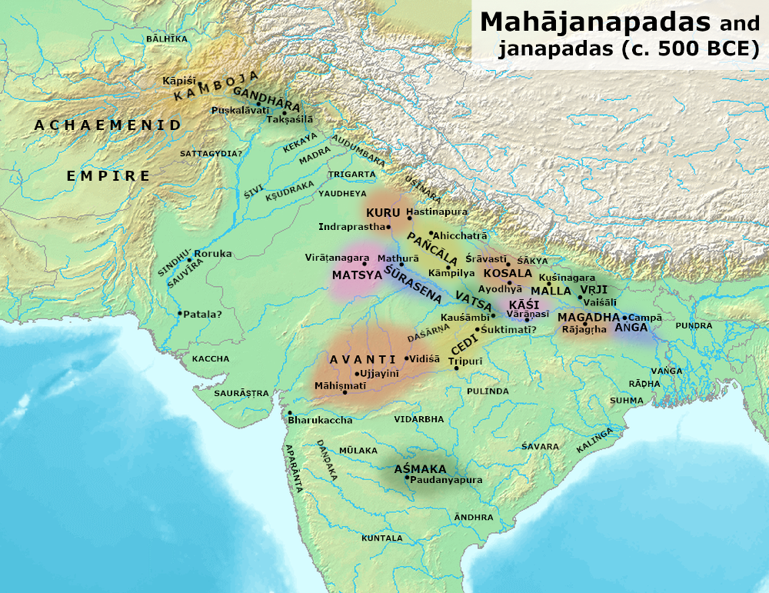

**The sixteen provinces of India during the Time of the Buddha [3]**

**Sixteen states:** 1 Anga 2 Asmaka 3 Avanti 4 Chedi 5 Gandhara 6 Kasi 7 Kamboja 8 Kosala 9 Kuru 10 Magadha 11 Malla 12 Matsya/Maccha 13 Panchala 14 Surasena 15 Vajji

16 Vatsa/Vamsa

### **Scriptural Evidence**

According to scriptures there were sixteen (AN3:70) great countries:

The Buddha said:

*“ Visākhā, one were to exercise sovereignty and kingship over these sixteen great countries abounding in the seven precious substances, that is, [the countries of] the Aṅgans, the Magadhans, the Kāsis, the Kosalans, the Vajjis, the Mallas, the Cetis, the Vaṅgas, the Kurus, the Pañcālas, the Macchas, the Sūrasenas, the Assakas, the Avantis, the Gandhārans, and the Kambojans…”[4]*

# Middle Country (*Majjhimadesa)*

According to the scriptures, the Buddha primarily travelled through the Middle Country (Majjhimadesa), also known as the central Ganges plain. Of the sixteen Mahājanapadas, fourteen were part of Majjhimadesa, with the exceptions of Gandhāra and Kamboja, which were considered part of Uttarāpatha (the northern region). [5] It is also stated that all Buddhas, as well as other enlightened beings capable of comprehending the Dhamma, are born in this region. [6]

During the Buddha’s time, Jambudīpa (ancient India) was said to span 10,000 yojanas, while Majjhimadesa measured approximately 300 yojanas in length, 250 yojanas in breadth, and 900 yojanas in circumference. [7]

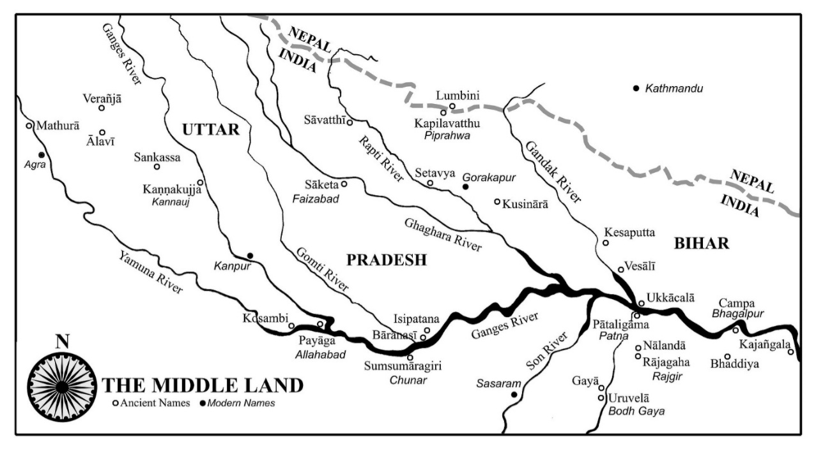

**Map showing the Middle Country during the time of the Buddha [8]**

### The Borders of the Middle Country

**In Vinaya Pitaka** we find a description given by the Buddha outlying the borders of Middle Country and border countries that surrounded it.

“ In this regard, the following is outside the central Ganges plain: In the eastern direction there is a town called *Gajaṅgala*, with another town called *Mahāsālā* just after it. Beyond it is outside the central Ganges plain. On the near side of it is the central Ganges plain. In the south-eastern direction there is a river called *Sallavatī*. Beyond it is outside the central Ganges plain. On the near side of it is the central Ganges plain. In the southern direction there is a town called *Setakaṇṇika*. Beyond it is outside the central Ganges plain. On the near side

of it is the central Ganges plain. In the western direction there is a brahmin village called *Thūṇa*. Beyond it is outside the central Ganges plain. On the near side of it is the central Ganges plain. In the northern direction there is a mountain called *Usīraddhaja*. Beyond it is outside the central Ganges plain. On the near side of it is the central Ganges plain” [9].

## Boundaries of the Middle Country (*Majjhimadesa*)

The Middle Country (*Majjhimadesa*), primarily located in the central Ganges valley, had well-defined borders as described in ancient scriptures. Below is a simplified overview of its geographical boundaries:

* Eastern Boundary: The easternmost point of *Majjhimadesa* was marked by the market town of *Kajaṅgala*. Beyond it lay the city of *Mahāsālā*, and further east were the outer boundary regions of the Middle Country.
* Southeastern Corner: The *Sallavatī* River marked the southeastern boundary. Beyond this river, the territory extended into regions outside *Majjhimadesa*.
* Southern Boundary: In the south, the town of *Setakaṇṇika* was the last settlement within the Middle Country. Beyond it lay the boundary regions that were considered outside its domain.
* Western Boundary: The westernmost point was the *brāhmaṇa* village of *Thūna*. Beyond this village, the land was no longer considered part of *Majjhimadesa*.
* Northern Boundary: In the north, the boundary extended to the slopes of *Usīraddhaja* mountain, which is believed to correspond to *Usiragiri*, a mountain located north of *Kaṅkhal* in *Haridwar, Uttarakhand*. Beyond this mountainous region lay the territories outside *Majjhimadesa*.

These boundaries defined the region in which the Buddha primarily travelled and taught, a land considered sacred as the birthplace of enlightened beings and the cradle of the Dhamma. [10]

Ancient Kajaṅgalā a market town situated 100 km south east of City of Champa and 80 km from city of Bhaddiya : current name is Kankjol, a small village in Sahibganji district in Jharkhand, it situated 18 km south of Rajmahal (a subdivisional town of the Sahebganj district) right on the Indo-Bangladesh border. The Indriyabhāvanā Sutta (MN:152) also mentions that on one occasion the Buddha was staying Kajangalā in a grove of mukhelu trees. In AN10:27 sutta mentioned an event occurred during the time of the Buddha was dwelling in Kajaṅgalā, Bhikkhuni Kajaṅgalā, delivering a discourse to some lay people from that place. In the Milinda-pañha, Kajaṅgalā is described as the birth place of Nāgasena Thero.

AN10:27 & AN10:28 give some information of the Buddha staying at Kajangalā.

### Some more information of boundaries of Majjimadesa:

Following source says this about the boundaries of Majjimadesa:

*“The boundaries of Majjhimadesa (Madhyadeśa) or the Middle country have been referred to and explained in both Brahmanical and Buddhist literature of an early date. Thus as early as the age of the Sūtras, we find, in the Dharmasūtra of Baudhāyana, Āryāvarta or the country of the Aryans (which is practically identical with the country later on known as Madhyadeśa) described as lying to the east of the region where the river Saraswatī disappears, to the West of the Kalakavana or Black Forest (identified with a tract somewhere near Prayāga),  to the north of Pāripātra and to the south of the Himalayas.” [11]*

# Places Where the Buddha Resided During the Rainy Seasons

To provide updated information on the locations where the Buddha spent the rainy seasons during his lifetime, we have primarily referred to the following ancient texts:

**Source 1:** Madhuratthavilasini nama- Buddhavamsatthakatha of Bhadantâcariya Buddhadatta Mahathera: Translated by I. B. Honer, 1946.

**Source 2**:Jinacaritaṁ: The Life of the Victorious Buddha: Original Pali Poem by Venerable Medhankara Thera: Edited and translated by Anandajoti Bhikkhu.

**Next is Section 13.1** where we will focus on the first year of the Buddha’s life after his enlightenment

### Endnotes: Section 13-Introduction

1. AI generated image
2. Source: <https://en.wikipedia.org/wiki/Mahajanapadas>
3. Source: <https://en.wikipedia.org/wiki/Mahajanapadas#/media/File:Mahajanapadas_(c._500_BCE).png>

   Attribution to the author: Avantiputra7.
4. “ Most of these states are located in the Indian subcontinent, but Gandhāra and Kamboja were in the northwest, corresponding to parts of modern Pakistan and Afghanistan”, see: AN: Note: 483.
5. Source: Geography of Early Buddhism by Bimala Churn Law: Chapter 1
6. DN: 33 (Sangiti Sutta) described who are the unfortunate or fortunate people born in middle country who would enhance in Dhamma.
7. Source: Geography of Early Buddhism: Chapter 1: Majjhimadesa or Middle Country- <https://ancient-buddhist-texts.net/Reference/Geography-of-Early-Buddhism/01-Middle-Country.htm>
8. Source: <http://wiswo.org/books/footprints/>
9. VP: Mahavagga: Cammakkhandhaka: 12, Theravāda Collection on Monastic Law translated by Bhikkhu Brahmali.
10. Some of these places are mentioned in: 1) Divyāvadāna or “Divine Tales”: a Sanskrit anthology of 38 tales of Mūlasarvāstivāda Vinaya 2) Geography of Early BuddhismbyB. C. Law.
11. Source: Geography of Early Buddhism: Chapter I: Majjhimadesa or Middle Country: <https://ancient-buddhist-texts.net/Reference/Geography-of-Early-Buddhism/01-Middle-Country.htm>